20.23: a) Combining Eq. (20.14) and Eq. (20.15),

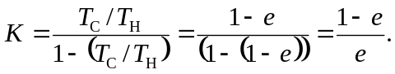

b) As and this is useless as a refrigerator. As 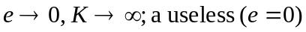engine does no work 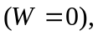and a refrigerator that requires no energy input is very good indeed.

